Game Design Document

Fill up the Following document

1. Write the title of your project.

Jerry and his Yearly Quest

1. What is the goal of the game?

Jerry has to run away from tom and reach his mouse hole safely with collecting cheese for the winter along the way.

1. Write a brief story of your game?

It will be very similar to a pac-man game mixed with a regular maze game with some changes, so in this game jerry will have to collect cheese on his quest to his rat hole safely without getting captured by tom. If he gets captured by tom he fails in his quest and dies.

1. Which are the playing characters of this game?

* Playing characters are the ones which respond to the user based on the input from the user
* Cars, monkeys, dinos, wizards etc, are the playing characters in the game.

|  |  |  |
| --- | --- | --- |
| Number | Character Name | What can this character do? |
| 1 | Jerry | Collect cheese and move with the help of arrows |
| 2 |  |  |
| 3 |  |  |
| 4 |  |  |
| 5 |  |  |
| 6 |  |  |
| 7 |  |  |
| 8 |  |  |

1. Which are the Non Playing Characters of this game?

* Non Playing characters are the ones which don't have an action or a behaviour when the user interacts with the game.
* Hurdles, stones, bananas, coins, etc are non playing characters in the game.

|  |  |  |
| --- | --- | --- |
| Number | Character Name | What can this character do? |
| 1 | Tom | Catch jerry |
| 2 | Cheese | Get collected |
| 3 |  |  |
| 4 |  |  |
| 5 |  |  |
| 6 |  |  |
| 7 |  |  |
| 8 |  |  |

Draw your imagination of this game. What does this game look like?

* Draw the game either on your computer or on paper,
* Add images of scenes of the game to show each of the playing and non-playing characters at least once.

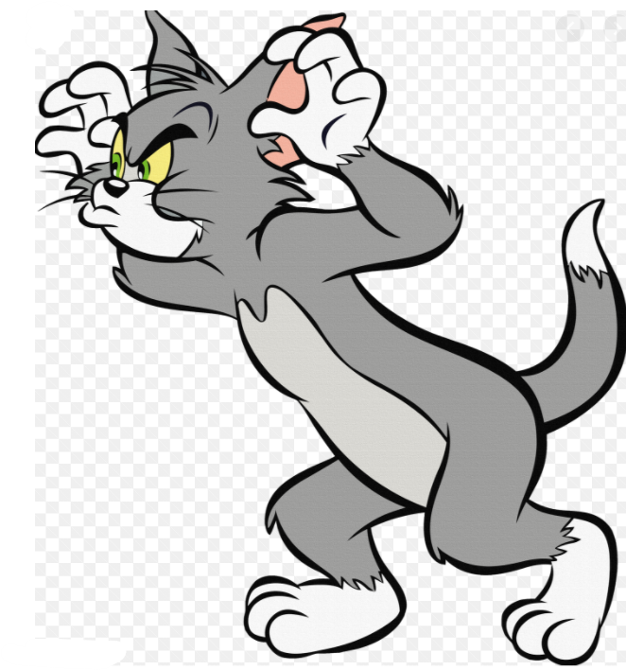 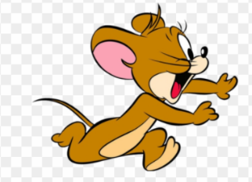 

How do you plan to make your game engaging?

It will have confusing paths and danger zones were tom moves twice his usual speed.